EXP NO :15
EMBEDDED C PROGRAM TO CONVERT THE HEXADECIMAL DATA 0XCFH
TO DECIMAL AND DISPLAY THE DIGITS ON PORTS P0, P1 AND P2
AIM:
To write an Embedded C program to convert Hexadecimal numbers into Decimal and display the digits on ports using Keil software.
SOFTWARE REQUIRED:
- Keil software
Program :
#include <reg51.h>

void main(void)
{
unsigned char hexa = 0x08;
unsigned char hundreds, tens, units;

ACC = hexa;
B = 10;
ACC = ACC / B;
units = B;
B = 10;
ACC = ACC / B;
tens = B;
hundreds = ACC;
P0 = units;
P1 = tens;
P2 = hundreds;
while(1);
}

Output :
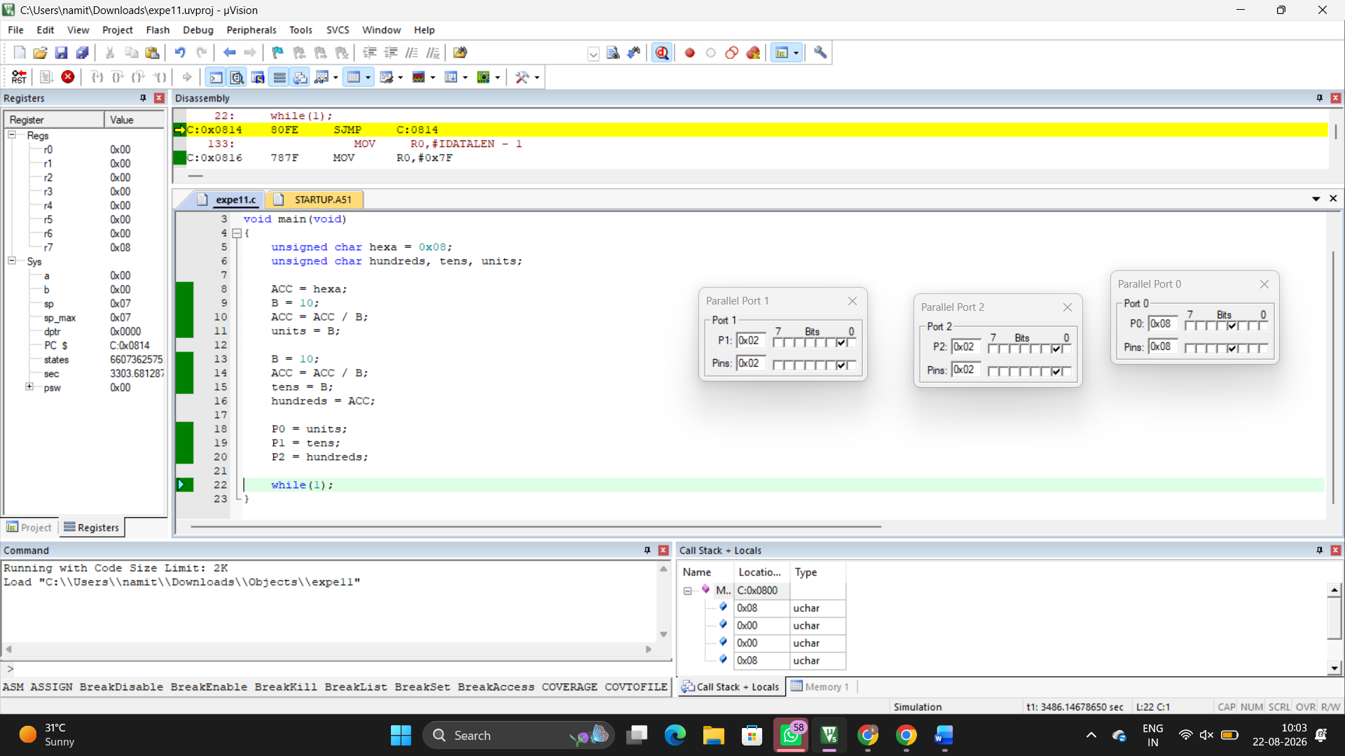
RESULT :
Thus the program has been successfully verified and verified.

